Experiment 3.1
Force between Two Electric Charges with Varying Distance

Code File Name: Exp3_1_ChargeForce_VaryingDistance.m
Code
clc;
clear;
close all;
q1 = input('Enter the charge q1 = ');
q2 = input('Enter the charge q2 = ');
epsilon = 8.854e-12;
k = 1/(4*pi*epsilon);
r = linspace(0.1,10,100);
F = k*q1*q2./(r.^2);
disp('Force at r = 1 m is:');
disp(k*q1*q2);
figure;
plot(r,F,'LineWidth',2);
grid on;
xlabel('Distance (m)');
ylabel('Force (N)');
title('Force between Two Electric Charges');
Command Prompt
Enter the charge q1 = 2e-6
Enter the charge q2 = 3e-6
Force at r = 1 m is:
0.0539
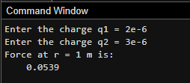

Output Graph
